Bug_id_01
Bug Description:
Keyboard Tab navigation is partially functional but fails to focus on critical links including Login, Privacy Policy, and Terms & Conditions links. While Tab moves focus between form fields, it completely skips all important navigation links, preventing keyboard-only users from accessing essential page functionality.
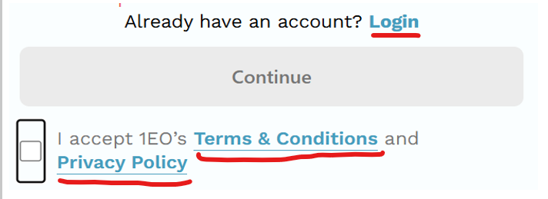

Bug_id_02
Bug Description:
Form data persistence is broken when navigating back from the Terms & Conditions page. All user-entered data including email and phone number gets cleared and lost when using the back button to return to the signup form, forcing users to re-enter all information.
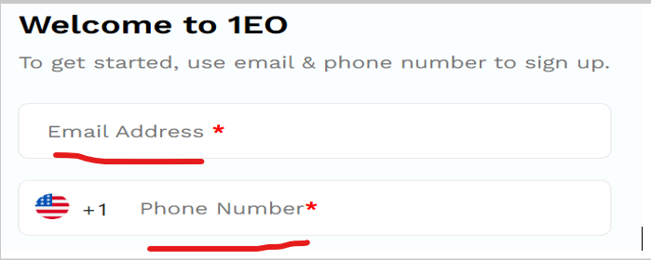
Reproduction Steps:
1. Navigate to: https://landing.stg.1earthop.com/become-a-seller
2. Enter Email: testuser@gmail.com
3. Enter Phone Number: +1 1234567890
4. Click "Terms & Conditions" link (navigates to Terms page)
5. Click Browser Back button to return to signup page
6. Observe that both fields are now EMPTY:
- Email field cleared
- Phone number field cleared
7. User forced to re-enter all information

Bug_id_03
Bug Description:
Inconsistent error message positioning is observed between email and phone fields. While the email error message appears correctly positioned immediately below its field, the phone error message displays significantly lower with excessive spacing, creating visual inconsistency and poor UI alignment.
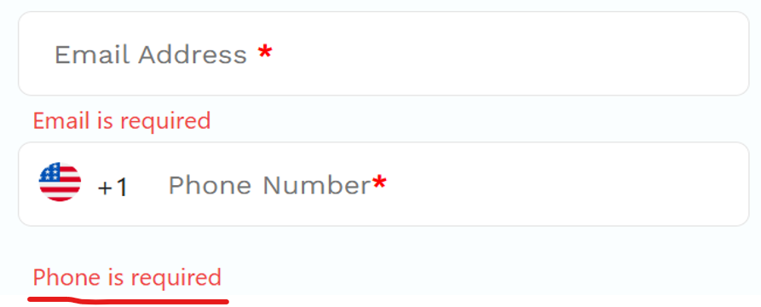

Bug_id_04
Bug Description:
The Login link lacks visual hover feedback, appearing as static text without any interactive cues. When users hover over the "Login" text, there is no color change, underline effect, or cursor pointer change, making it indistinguishable from non-clickable text and providing poor user experience.


Bug_id_05
Bug Description:
The Login link is missing the essential href attribute, making it non-functional as a hyperlink. The "Login" text exists as plain content without any underlying URL destination, preventing both user clicks and right-click "Open in new tab" functionality.
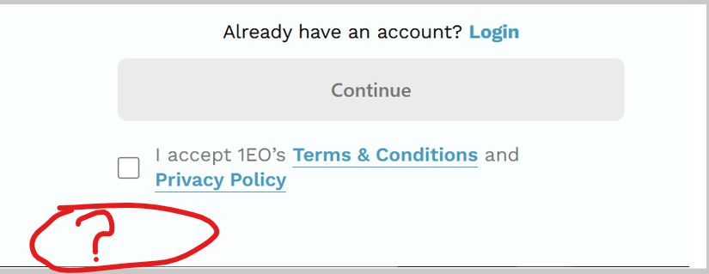

Bug_id_06
Bug Description:
Statistics section has inconsistent vertical divider styling and alignment. The first divider (|) appears correctly sized while the second divider is noticeably smaller, and the left section is poorly aligned compared to the properly centered middle and right sections, breaking visual harmony. 

Bug_id_07
Bug Description:
The phone number field fails to clear when users change their country selection, causing invalid phone number formats to persist. When switching between countries with different dialing codes, the previously entered number remains in the field, creating potential format conflicts and user confusion.
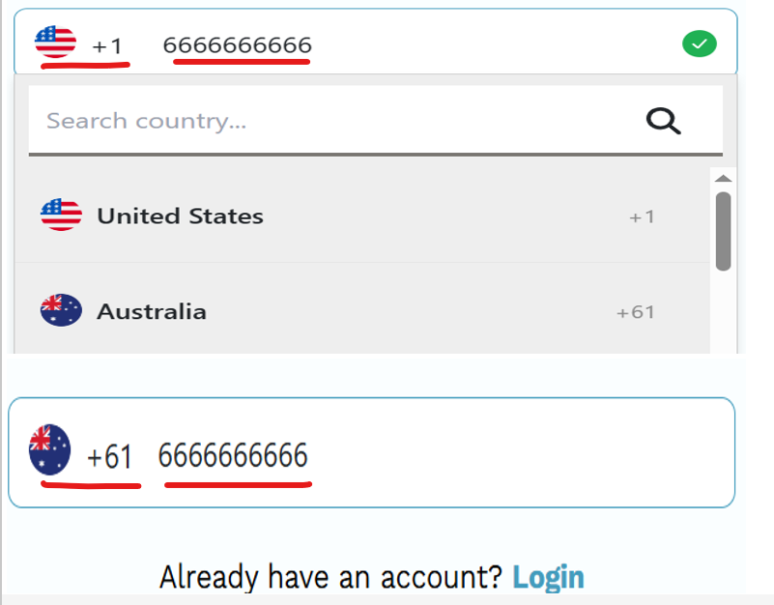
Reproduction Steps:
1. Navigate to: https://landing.stg.1earthop.com/become-a-seller
2. Select Country: United States (+1)
3. Enter Phone Number: 6666666666
4. Click Country dropdown again
5. Select Different Country: Australia (+61)
6. Observe Phone Field still shows: 6666666666
7. Expected: Field should CLEAR automatically
8. Current: Old US number persists with new AU code (+61 6666666666)

Bug_id_10
Bug Description:
The browser back button fails to properly navigate users from the Terms & Conditions page back to the signup form. While the URL changes in the address bar, the page content remains stuck on the Terms & Conditions page instead of displaying the signup form, effectively trapping users.

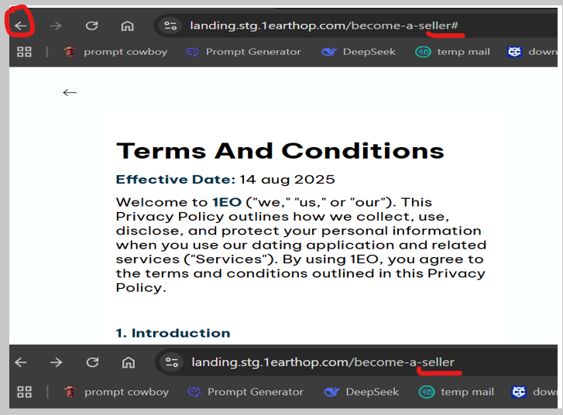

Reproduction Steps:
- Navigate to: https://landing.stg.1earthop.com/become-a-seller
- Enter Email: testuser@gmail.com
- Enter Phone Number: +1 1234567890
- Click "Terms & Conditions" link
- Verify URL changes to: https://landing.stg.1earthop.com/become-a-seller#
- Click Browser Back Button (←) in browser toolbar
- Observe URL changes back to original signup URL
- BUT page content REMAINS on Terms & Conditions page
- User is TRAPPED - cannot return to signup form

Bug_id_11
Bug Description:
The email validation system displays a generic "Invalid email" error message instead of the more specific and helpful "Invalid email format" message. This lacks clarity and doesn't guide users properly to fix their input, as the current message could imply various issues (domain not found, email already exists, etc.) rather than specifically indicating formatting problems.
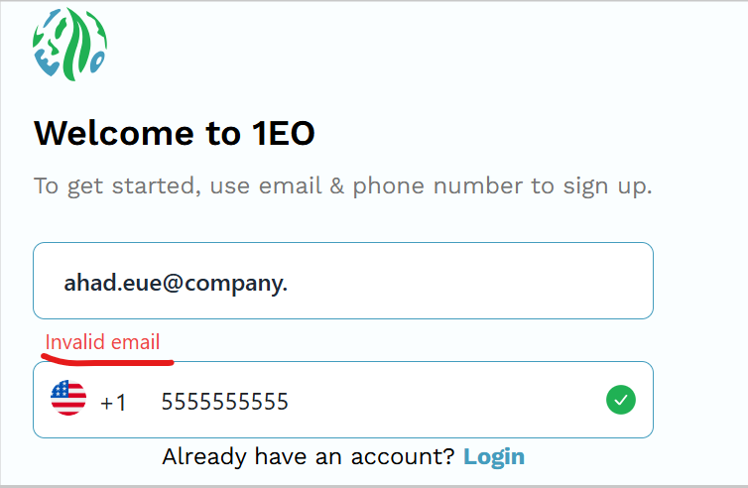
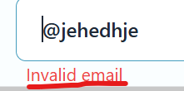

Bug_id_13
Bug Description:
Continue button response time is excessively slow, taking approximately 3 seconds to navigate from signup page to OTP verification page. This significant delay creates poor user experience, making the application feel unresponsive and potentially causing user abandonment during critical registration flow.
Bug_id_14
Bug Description:
The browser back button fails to properly navigate users from the Privacy Policy page back to the signup form. While the URL changes in the address bar, the page content remains stuck on Privacy Policy page instead of displaying the signup form, effectively trapping users.
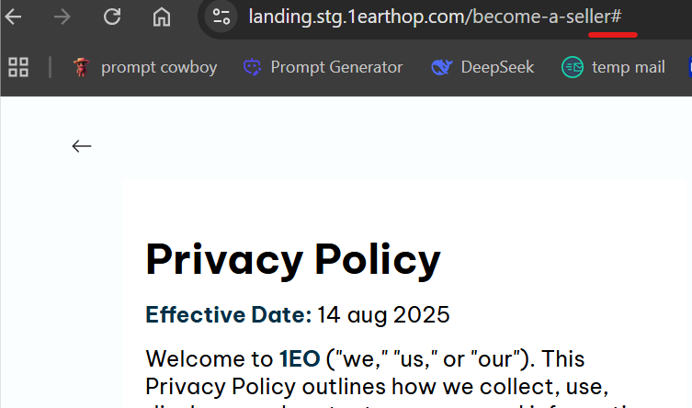
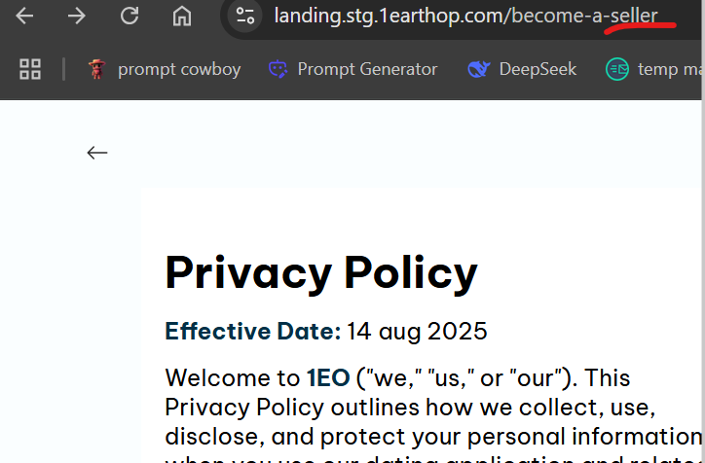

Bug_id_15
Bug Description:
Phone number validation is completely broken, allowing submission of invalid phone numbers with insufficient digits. The system accepts 5-digit phone numbers (88888) instead of enforcing minimum 10-digit requirement, proceeding to OTP page despite invalid format, compromising data integrity.
